3.5 Derivative of Trigonometric Functions

Motivation:
Suppose we want to find the first derivative of . If we use the definition of the derivative, we obtain:

Theorem: If x is measured in radians, we have:

- (2)

Proof (of 1):
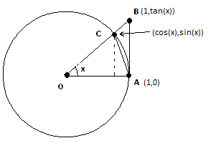
We note that since x is approaching zero we may assume that x is the measure of an acute angle. Using the figure to the right, we compute 3 different areas:

Theorem:

Proof:
Using the computation from the motivation we have that:

Example 1: Use the definition of the derivative to find .
(Hint: )

Example 2: Use the quotient rule to find the first derivative of each of the following.

Summary of Trig Function Derivatives:

Example 3: Suppose that the position of an object on a vertical spring at time t is given by the function: . Find a function for the velocity of the object at time t.

Example 4: Differentiate .

